Web App Lab #04:

Server Side- PHP, SQL Injections

Lab Overview:

In this lab you will:
- Test out PHP Login application on your newly installed WAMP server
- Create a registration application
- Explore the topic of SQL injections with examples of three attacks.

Lab Order:
- Download source files:
- Simple Login Screen
- SQL Injection
- SQL Injection: Example 1
- SQL Injection: Example 2 : Piggy Backed query
- SQL Injection: Example 3 : Union Query

Lab Tasks:

- Download Source Files
- Given files spies.html and spies.php on Blackboard. Download and save them on C:\wamp64\www or Docker HTML folder in a folder called Lab4
- There is a zipped version of these files also on Blackboard- SpiesZipped.zip – this can be used as backup, if individual files don’t download correctly.

- spies.html contains a form that allows a user to enter his/her firstname and surname. Do not modify spies.html in any way.
- spies.php contains a server-side PHP program. The program receives the user's firstname and surname from the form. The program outputs a Web page that greets the user in 007-fashion. For example, if the user enters 'James' and 'Bond', the Web page will contain the following paragraph:
Your spy name is: Bond, James Bond.

If the user enters 'Mary' and 'Ryan', the Web page will output:
Your spy name is: Ryan, Mary Ryan.

- To run:
At URL : localhost/Lab4/spies.html

- Identify client side, server side processing :
- Right click VIEW SOURCE on each web page
- Notice : URL passing data to spies.php

- Simple Login screen

- Using phpMyAdmin, create a new database and call it my_db
- Create a table in this database, call it persons
- Structure as below- 4 fields
  - Name varchar(20)
  - username varchar(15)
  - password varchar(15)
  - email varchar(20) – primary key
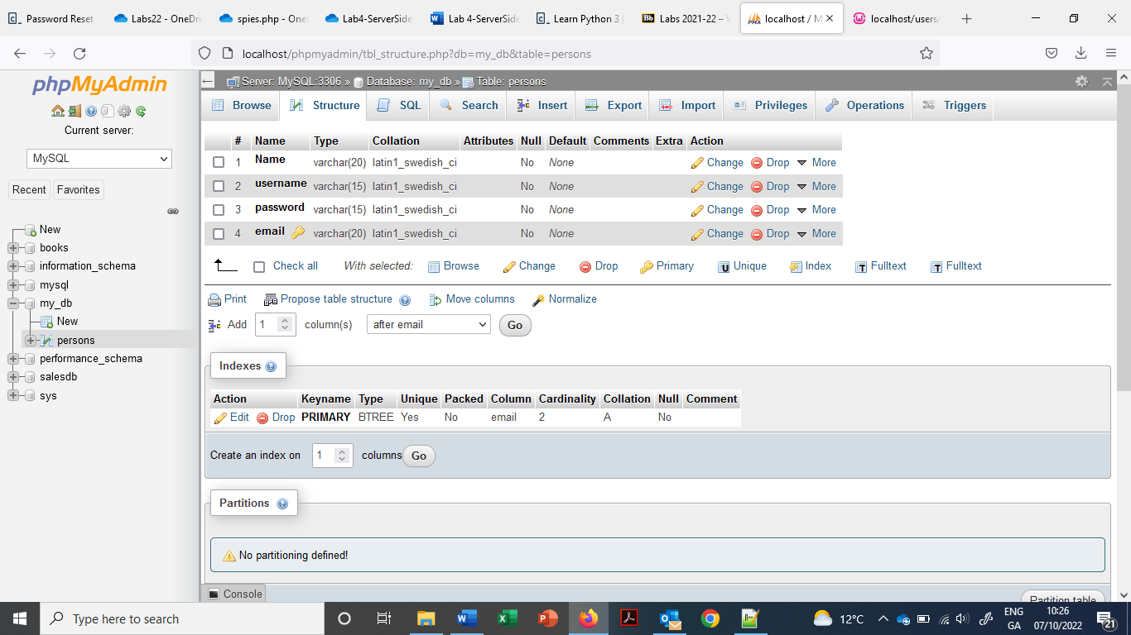
- Insert 4-5 rows of data to this table

- Create a folder called Users on C:\wamp64\www

- Paste the following into a new file login.html and save in Users folder

<html>
<head>
<title>Login Page</title>
</head>
<form action = "SimLogin.php" method = "POST">
<label>UserName :</label><input type = "text" name = "username" /><br /><br />
<label>Password :</label><input type = "password" name = "password" /><br/><br />
<input type = "submit" value = " Submit "/><br />
</form>

</body>
</html>

- Paste the following into new file Simlogin.php and save in Users folder also

<?php
$conn = mysqli_connect ("localhost","root","","my_db");

$myusername = $_POST['username'];
$mypassword = $_POST['password'];

$sql = "SELECT * FROM persons WHERE username = '$myusername' and Password = '$mypassword'";

echo $sql."<br><br>";
$result = mysqli_query($conn,$sql);

if(mySQLi_num_rows($result)>0) {

while ($row=mySQLi_fetch_row($result)){
echo "Valid User <br>";
echo "Name:". $row[0]. "<br> Email: ".$row[3];
}
}
else echo "Invalid user id or password";

?>

- To run:
At URL: localhost/Users/login.html

- Check it out with valid input and invalid input.

- SQL Injection *** WILL BE DEMO’D ***

- SQL Injection (SQLi) is a type of an injection attack that makes it possible to execute malicious SQL statements. These statements control a database server behind a web application. Attackers can use SQL Injection vulnerabilities to bypass application security measures.

- SQL Injection: Example 1

- for password type test' or 'x'='x

- Examine the SQL being executed

- What is the outcome?

- SQL Injection: Example 2 : Piggy Backed query
- Create a basic student table unto your database
- Going to change mysqli_query command to mysqli_multi_query
- Replace SimLogin.php with this

<?php
$conn = mysqli_connect ("localhost","root","","my_db");

$myusername = $_POST['username'];
$mypassword = $_POST['password'];

$sql = "SELECT * FROM persons WHERE username = '$myusername' and Password = '$mypassword'";

echo $sql."<br><br>";
$result = mysqli_multi_query($conn,$sql);
if ($result) echo "DONE";
else echo "NOT Done";

?>
- For password type: test' ; drop table student;

- Examine the SQL being executed

- What is the outcome?

- SQL Injection: Example 3 : Union Query
- Using SimLogin.php from Example 2

- For username type: ‘ UNION Select * from persons; --

- Examine the SQL being executed

- What is the outcome?

